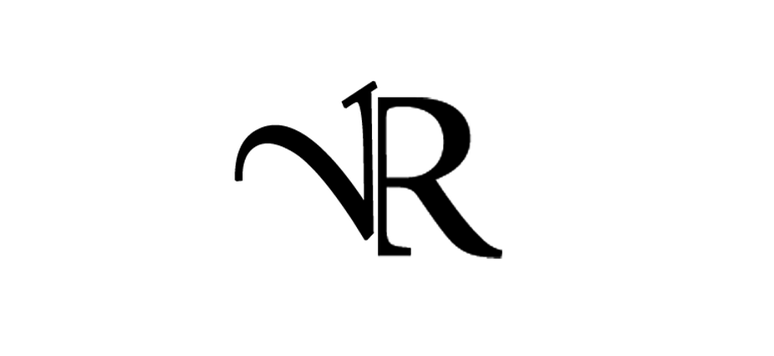

Bio
Valentina was born in Rome, Italy. She started her career at a very young age participating to different TV Shows and touring and performing with her father’s band. Coming from a Musical family she was always encouraged to study and improve, so she started with learning guitar, then bass, piano and drums.
She wrote her first piece of music on guitar at age of 10 years old.
She continues to work in Italy with different bands, performing on TV Shows and touring with artists all around the country as a lead and backing vocalist.
She moved to London 9 years ago to further her career in music and work as a singer. She's also a songwriter-producer and a DJ. She now performs in famous venues In London as well as other countries collaborating with several international artists and producers.

Click link to watch videos
https://www.youtube.com/watch?v=gygKMGEzbzk

https://youtu.be/BJjfpgEcT5U

http://www.valentinarusso.com

