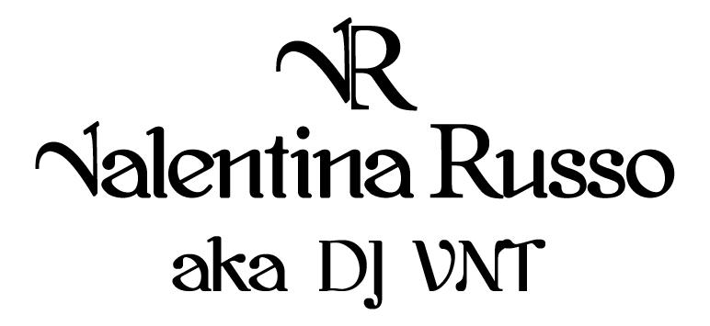

CLICK LINK TO PLAY VIDEO

https://youtu.be/HzeCLfiRskQ

BIO

Valentina aka DJ VNT started her career as a DJ more than 10 years ago, playing in some of the best clubs in Rome, then moved to London to continue her career and since then has played in many bars, clubs, hotels, private parties around England and in other countries. She loves to compile all kinds of music, from many genres rnb , soul, funk, house, deep house, all the best commercial releases from classics to current, disco, reggeaton, afrobeats, 80’s 90’s and many more.
She is able to mix with ease the genres, she loves to read the crowd and make everyone move their feet. A versatile Dj that top hotel chains and night clubs use as a resident Dj for private parties and their returning client base.

SOUNDCLOUDS LINKS
https://soundcloud.com/djvnt/commercial-remix

https://soundcloud.com/djvnt/mix-of-the-best-soulful-deep-house-tech-house-house-music-dj-vnt

https://soundcloud.com/djvnt/mix-dj-vnt-valentina-russo

